**21st Annual Chuck DuChon/Jim Rattigan**

**Memorial Golf Tournament**

**Format:** Captain’s Choice, scramble, 4-person team;

**Where:** Bowie Golf & Country Club

**When:** Friday August 22, 2025 9:00am Shot Gun Start

Men play from White; Seniors (60+) play from Gold;

Women play from Red;

**Pricing**

**Golf Foursome $500**

Tournament entry for 4 including green fees, cart, Mulligans, Long Drive & Closest to the Pin contests, 5-alcoholic drink tickets per player, Gatorade, soda, water, meal

**Individual Golfer $125**

Tournament entry for 1 including green fees, cart, Mulligans, Long Drive & Closest to the Pin contests, 5-alcoholic drink tickets, Gatorade, soda, water, meal

**Reception & Award Ceremony Only $30**

Entry for 1 to the Reception & Awards Ceremony**.**

**Proceeds to Benefit:**

**The American Cancer Society The American Diabetes Association**

in memory of Chuck DuChon in memory of Jim Rattigan

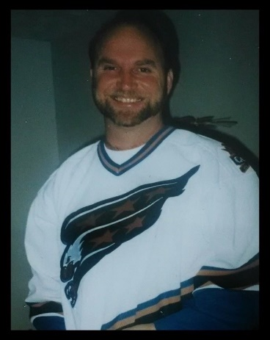  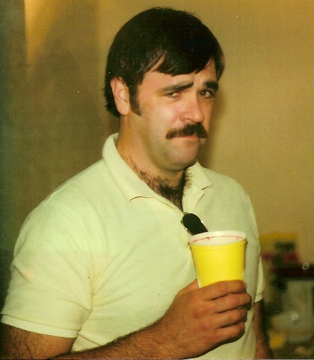

**Deadlines:**

**August 1 - To register or sponsor a hole**

**August 8 - To withdraw with refund**

**Contacts:**

**Walt Moleski Mike Pecnick**

**240-687-1661 (c) 301-502-0345 (c)**

[wfmoleski@gmail.com](mailto:wfmoleski@gmail.com) wxbucky@gmail.com

**Other Tournament Committee Members: Gary Stewart, Alex Ellison, Jim Abeles,**

**Sara DuChon & Joan Rattigan**

Rat & Chuck Tournament Registration form

Make checks payable to Mike Pecnick. Mail payment and registration form to Mike Pecnick, 304 Buckland Ct., Severna Park, MD 21146. Payment may also be made via PayPal by sending it to me personally at <https://www.paypal.me/WaltMoleski>. **If you are paying via PayPal, please remember to send as a “friend”. Any fees charged by PayPal are your responsibility and will be asked for at Registration.** Registration may also be made on our website at <http://ratchuckgolftourny.gsfcsoftball.org/>. Remember that you still need to send your payment via one of the methods above.

**NOTE: Registered groups will be placed into the tournament once payment is received.**

**Player Registration**

Please enter each player’s name and their e-mail and home addresses.

Player 1 Name:

(Captain)

Email:

Address:

Player 2 Name:

Email:

Address:

Player 3 Name:

Email:

Address:

Player 4 Name:

Email:

Address:

# **Sponsorship**

**Corporate Sponsor $500**

Your Company’s Logo on a Hole Sponsor sign and signage at Reception Pavilion

**Hole Sponsor $125**

Tee sponsor sign at one (1) hole

Sponsor’s Name and e-mail address:

Sponsorship type:

Please indicate what you would like to appear on your sign.

­­­­­­­­­­­­­­­­­